

Patrick Waren

Assignment 7 – A7



October 23, 2017

CIS 310-01

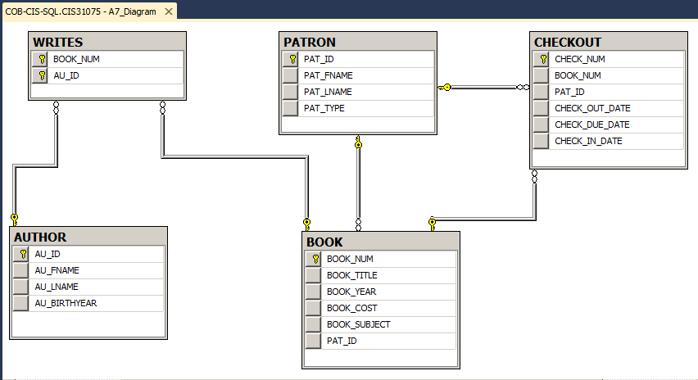

--Patrick Warren

--CIS 310-01

--Assignment 7

--65

SELECT BOOK_TITLE, BOOK_COST, BOOK_YEAR

FROM BOOK

--66

SELECT PAT_FNAME, PAT_LNAME

FROM PATRON

--67

SELECT CHECK_NUM, CHECK_OUT_DATE, CHECK_DUE_DATE

FROM CHECKOUT

--68

SELECT BOOK_NUM, BOOK_TITLE, BOOK_YEAR

FROM BOOK

--69

SELECT DISTINCT BOOK_YEAR

FROM BOOK

--70

SELECT DISTINCT BOOK_SUBJECT

FROM BOOK

--71

SELECT BOOK_NUM, BOOK_TITLE, BOOK_COST

FROM BOOK

--72

SELECT CHECK_NUM, BOOK_NUM, PAT_ID, CHECK_OUT_DATE, CHECK_DUE_DATE

FROM CHECKOUT

ORDER BY CHECK_OUT_DATE DESC

--73

SELECT BOOK_TITLE, BOOK_YEAR, BOOK_SUBJECT

FROM BOOK

ORDER BY BOOK_SUBJECT ASC, BOOK_YEAR DESC, BOOK_TITLE ASC

--74

SELECT BOOK_NUM, BOOK_TITLE, BOOK_YEAR

FROM BOOK

WHERE BOOK_YEAR = 2012

--75

SELECT BOOK_NUM, BOOK_TITLE, BOOK_YEAR

FROM BOOK

WHERE BOOK_SUBJECT = 'Database'

--76

SELECT CHECK_NUM, BOOK_NUM, CHECK_OUT_DATE

FROM CHECKOUT

WHERE CHECK_OUT_DATE < '2015-4-5'

--77

SELECT BOOK_NUM, BOOK_TITLE, BOOK_YEAR

FROM BOOK

WHERE BOOK_YEAR > 2013 AND BOOK_SUBJECT = 'Programming'

--78

SELECT BOOK_NUM, BOOK_TITLE, BOOK_YEAR, BOOK_SUBJECT, BOOK_COST

FROM BOOK

WHERE (BOOK_SUBJECT = 'Middleware' OR BOOK_SUBJECT = 'Cloud') And BOOK_COST > 70

--79

SELECT *

FROM AUTHOR

WHERE AU_BIRTHYEAR >= '1980' AND AU_BIRTHYEAR <= '1989'

--80

SELECT BOOK_NUM, BOOK_TITLE, BOOK_YEAR

FROM BOOK

WHERE BOOK_TITLE LIKE '%DATABASE%'

--81

SELECT PAT_ID, PAT_FNAME, PAT_LNAME

FROM PATRON

WHERE PAT_TYPE LIKE '%STUDENT%'

--82

SELECT *

FROM PATRON

WHERE PAT_LNAME LIKE 'C%'

--83

SELECT AU_ID, AU_FNAME, AU_LNAME

FROM AUTHOR

WHERE AU_BIRTHYEAR IS NULL

--84

SELECT AU_ID, AU_FNAME, AU_LNAME

FROM AUTHOR

WHERE AU_BIRTHYEAR IS NOT NULL

--85

SELECT CHECK_NUM, BOOK_NUM, PAT_ID, CHECK_OUT_DATE, CHECK_DUE_DATE

FROM CHECKOUT

WHERE CHECK_IN_DATE IS NULL

ORDER BY BOOK_NUM

--86

SELECT *

FROM AUTHOR

ORDER BY AU_BIRTHYEAR DESC, AU_LNAME ASC

--87

SELECT COUNT(BOOK_NUM) AS [Number of Books]

FROM BOOK

--88

SELECT COUNT(DISTINCT BOOK_SUBJECT) AS [Number of Subjects]

FROM BOOK

--89

SELECT COUNT(BOOK_NUM) AS [Available Books]

FROM BOOK

WHERE PAT_ID IS NULL

--90

SELECT MAX(BOOK_COST) AS [Most Expensive]

FROM BOOK

--91

SELECT MIN(BOOK_COST) AS [Least Expensive]

FROM BOOK

--92

SELECT COUNT(DISTINCT PAT_ID) AS [Different Patrons]

FROM CHECKOUT

--93

SELECT BOOK_SUBJECT, COUNT(BOOK_SUBJECT) AS [Books in Subject]

FROM BOOK

GROUP BY BOOK_SUBJECT

ORDER BY COUNT(BOOK_SUBJECT) DESC, BOOK_SUBJECT ASC

--94

SELECT AU_ID, COUNT(BOOK_NUM) AS [Books Written]

FROM WRITES

GROUP BY AU_ID

ORDER BY COUNT(BOOK_NUM) DESC, AU_ID ASC

--95

SELECT SUM(BOOK_COST) AS [Library Value]

FROM BOOK